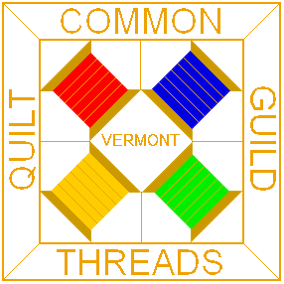
Common Threads Quilt Guild
of Lamoille County, Vermont
c/o Insert Your Name
Address
City, State Zip

