_________
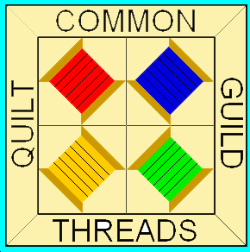
No.

A Harvest of Quilts
Presented by

Common Threads Guilt Guild

People’s Academy Gymnasium, Morrisville, VT 05661

October 7 & 8, 2017

Registration Form

Deadline: Thursday, July 6, 2017

Please print clearly:

Name: ____________________________________________ Address: __________________________________________

Phone: __________ Email: _____________________________ __________________________________________

Title of Quilt: _____________________________________________________________________________

Brief Description: __________________________________________________________________________

__________________________________________________________________________

Category: (Check all that apply)

_____ Lap & Baby Quilts ____ Bed Quilt ___Miniature ____ Table Runners ____Wallhanging
(up to 60 “ long) (60 “ W; 80”L & up) (no more 15x20)
Hanging dimensions of entry in inches : ______(width) by ______(length) ______ Wool Appliqué

Note : Quilts must have a 6`` sleeve for hanging.

Check all that apply :

_____Machine pieced _____Hand pieced _____Machine appliqued _____Hand appliqued

_____Machine quilted _____Professionally machine quilted _____Hand quilted

Other techniques used : ________________________________________________________________________________

Pieced by whom ________________________________ Quilted by whom _____________________________________

Name of piecing design ___________________________
Photograph Enclosed __________
Sources of design ________________________________

Is Quilt for Sale ? Yes ___ No___ Price __________ The Guild will take $10% for any quilts sold from the quilt display.

Common Threads Quilt Guild and People’s Academy is not responsible for damaged or loss of quilts exhibited. I accept full responsibility
for insurance coverage.

Signature : ______________________________ Date : ____________

Mail 2 copies of completed form and 1 photograph to :

Rita Lehouillier, Registration Chair, 798 Sterling View Rd, Hyde Park, VT 05655

